Running the program
1. Download Processing from here and open it. A window should pop up in which you can enter code.
2. Go to Sketch -> Import Library -> Add Library... and another window should open.
3. In the top left of this new window, search "minim", click on the result labeled "Minim" and click the "Install" button in the bottom right. Wait for the install to finish.
4. Download the keyboard code from here.
5. Close Processing entirely and re-open it.
6. In Processing, press Ctrl-O, find the keyboard code, and open it. A window will pop up saying that the sketch needs to be moved into a folder. Click "Yes". The code should now be open in the Processing window.
7. Press Ctrl-R or click the circle with a triangle inside in the top left and the program should run.
Playing the piano
The following image shows which keys on your keyboard correspond to which keys on the piano:
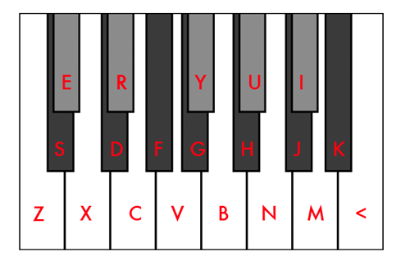
Additionally, press + and - to bring the keyboard up and down an octave respectively, and press 1 through 5 to switch between 5 different instruments.

Have fun!

